**Violin plot**

*Categorical Axis*: The x-axis usually represents a categorical variable.

*Numerical Axis*: The y-axis represents a continuous variable.

*Jittering*: The data points are jittered slightly on the x-axis so that points don’t overlap, making it easy to see the number of data points and their distribution.

1. *No Overlap*: Unlike strip plots, swarm plots automatically adjust the position of points to avoid overlap, making it easier to see the density of points.

2. *Clarity*: Each data point is clearly visible, allowing for a better understanding of the distribution of values.

3.*Detailed Insight*: Swarm plots provide more granular insights compared to boxplots because they show each observation rather than just summary statistics.

**"What is the distribution of salaries for each SSC board?"**

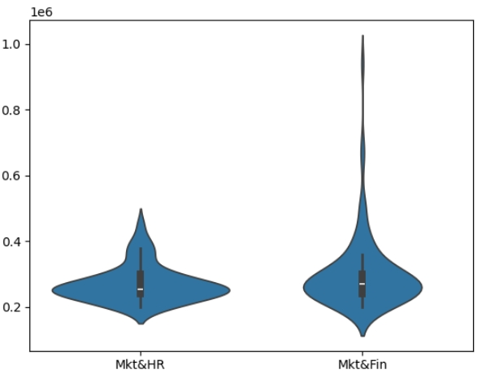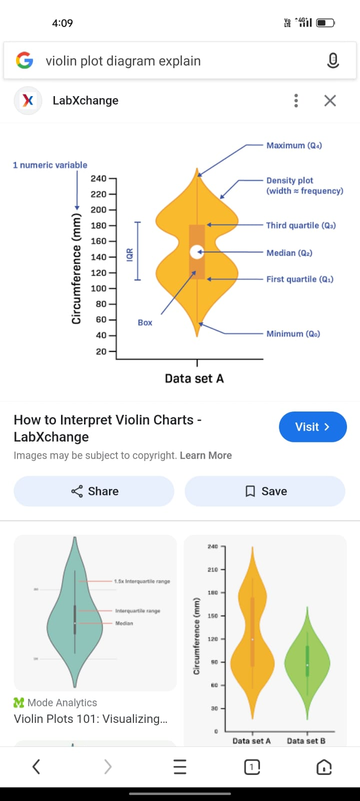

**Summary of the Violin Plot:**

- The *density* for the 'mk & hr' specialization is higher compared to the 'mk & fin' specialization. This means that more individuals in 'mk & hr' fall within a narrower salary range.

- The *mk & fin* shows a more spread-out distribution of salary values, indicating that salaries are more varied

- For 'mk & hr', the data is more concentrated around the median- For 'mk & fin', the plot shows a more balanced spread of salaries, indicating variability in salary outcomes for individuals with this specialization.

**Swarm Plot**

"What is the salary difference between males and females?"

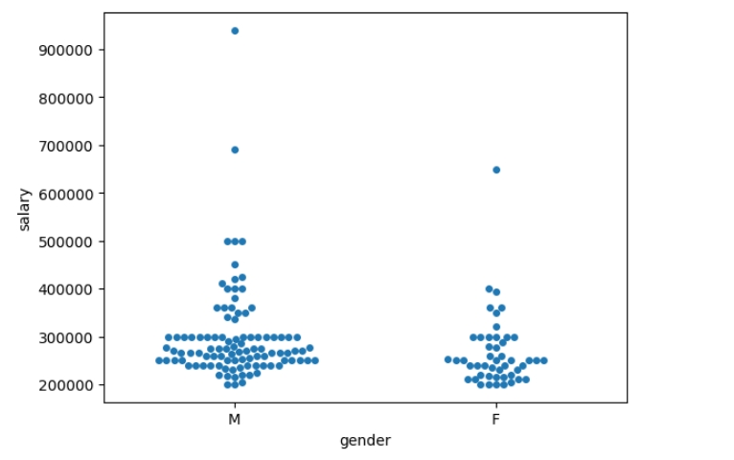

1. Majority of salaries are between 200,000 and 400,000.
2. males and females have salaries within the maximum range (200,000 to 300,000), but males higher range compared to females.
3. Outliers include one male earning 900,000, one male 700,000, three males 500,000, and one female 600,000.
4. Swarmplot will show that, despite overlapping salary ranges, males generally have higher salaries compared to females.